**Class Exercise - 3.2**

**Name: Patrick Woodrum**

**Clemson ID: C79975506**

**Submission**: Save this Word document with your answers as a PDF file and upload the PDF file to Canvas.

**Forest Point Construction**

At Forest Point Construction, your boss says that he can estimate the total project time based on his personal experience. You are trying to convince him that he should use project management techniques to handle a complex project. To prove your point, you decide to use a simple example of a commercial steel building construction project, with eight steps. You create a hypothetical work breakdown structure, as follows:

* Prepare the site (3 days), and then set the building footers (3 days).
* Finish the foundation (5 days), and then assemble the building (3 days).
* When the building is assembled, start two tasks at once: finish the interior work (5 days) and set up an appointment for the final building inspection (15 days).
* When the interior work is done, start two more tasks at once: landscaping (7 days) and driveway paving (3 days).
* When the landscaping and driveway are done, do the painting (2 days).
* Finally, when the painting is done and the final inspection has occurred, arrange the sale (2 days).

Use one of the project management tools identified on the “External Tools Page” in Canvas.   
You’ll also need such a tool for this chapter’s case study.

Do the following:

1. Create a Gantt chart, take a screen shot and paste an image of it here:

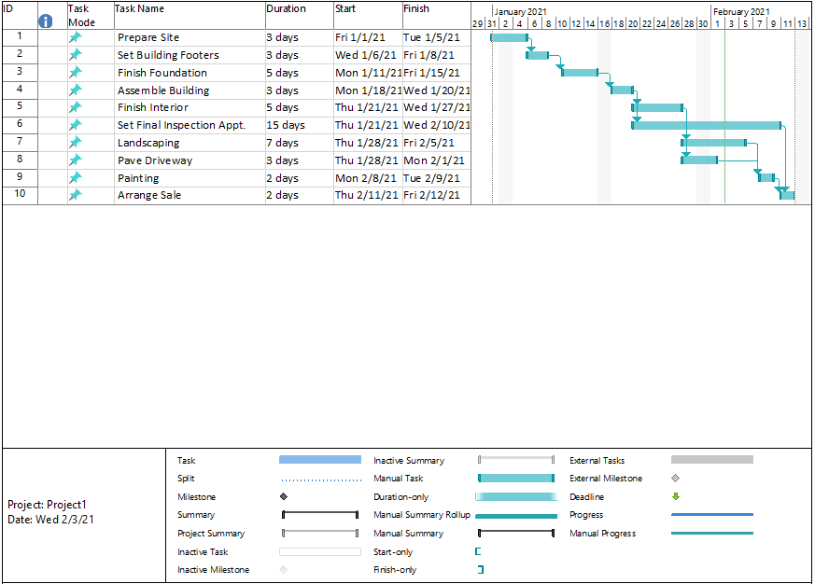

1. What is the critical path (list the tasks by ID)?

**Critical Path:**

1. **ID: 1 – Prepare Site**
2. **ID: 2 – Set Building footers**
3. **ID: 3 – Finish Foundation**
4. **ID: 4 – Assemble Building**
5. **ID: 6 – Set Final Inspection Appointment**
6. **ID: 10 – Arrange Sale**
7. If the project started on January 1, what is the finish date?

**February 12, 2021**